Luca Csepely-Knorr

Manchester School of Architecture

**Mawson, Thomas Hayton (1861-1933)**

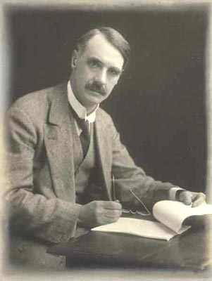

Thomas Hayton Mawson

http://www.visitcumbria.com/photos/thm.jpg

The self-trained English landscape architect and town planner Thomas Hayton Mawson became one of the most successful designers of the first decades of the 20th century. He started his career as a nurseryman, founding the family business Mawson Brothers’ Lakeland Nurseries in Windemere in 1884. A few years later he separated the design part of the business and began to run his own consultancy. His office, Thomas H. Mawson and Sons, quickly became successful and included influential and powerful clients like Andrew Carnegie (1835-1919) and William Hesketh Lever (1851-1925). They even designed gardens for royals like Alexandra of Denmark (1844-1925) and King Constantine of Greece (1868-1923).

After the success of his plans, Mawson decided to write a book about his experience as a garden designer. *The Art and Craft of Garden Making* was first published in 1900, and soon became a bestseller of the time. Besides the success of having five editions in his lifetime, it brought Mawson an international reputation, and was cited as the “best work on the contemporary conception of the English garden” by Herman Muthesius. His principles such as the aim of creating spatial and aesthetic unity between the house and the garden, the ‘room-like’ enclosures of spaces, and the use of materials such as asphalt, metal and concrete foreshadowed the thinking embodied in of the modernist gardens.

Mawson turned his attention to the questions of designing urban open spaces at the turn of the 20th century. He started out designing public parks, but was soon involved in larger scale plans as well. As Mawson realised, the problems of public parks were not separable from the broader issues of cities. Therefore he constantly argued in his designs and in his writings for the integration of landscape architecture into town planning and aimed to create a bridge between designing gardens and urban open and green spaces. He first summarised his knowledge about the city in 1911 in his book, *Civic Art*. In this he defined core ideas such as park systems for cities, and framed a coherent typology of urban open spaces and connected stylistic solutions to it. Parallel to his garden designs, he was a keen advocate of the spatial and stylistic harmony between the built environment and open spaces. However, the link between the city and the surrounding broader landscape was no less important to him. His complex way of thinking of green and open spaces as systems anticipated the open space plans of London and Berlin. He produced city plans for Canada, designed the city development for Athens and among others for Blackpool and Bolton in England.

Partly because he was a self-trained professional himself, and also to gain more recognition for his profession, Mawson campaigned tirelessly for higher education for landscape architects. He became the teacher of landscape design at the School of Civic Design in Liverpool University’s School of Architecture. Besides teaching, he wrote a considerable body of articles on the role of landscape architecture.

**List of selected garden designs**

1899-1912 Graythwaite Hall, Lancashire, England

1899-1900 Brockhole, Windermere, England

1904 Skibo Castle, Sutherland, England

1905 Roynton Cottage, Lancashire, England

1905 Rivington, Lancashire, England

1906-14 Thornton Manor, Cheshire, England

1908 Rodborough Court, Gloucestershire, England

1908 Angervilliers, Paris

1908 Hvidöre, Copenhagen, Denmark

1908 The Peace Palace, The Hague, Netherlands

1909 Rydal Hall, Ambleside, England

1912 Graythwaite Estate, Cumbria, England

1913-14 Palace Gardens, Athens, Greece

**List of selected town planning works**

1906 Port Sunlight, England

1910-16 Bolton, Lancashire, England

1912 Coal Harbour, Vancouver, Canada

1913 Calgary town plan, Canada

1913-14 Athens city plan

1913-23 Exeter of the Future, England

1917 Thessaloniki garden city settlements, Greece

1918 Stephney, England

1925 Blackpool Town Planning Scheme

**References and further reading**

Cherry, G. E., Jordan, H., Kafkoula, K. (1993) ‘Gardens, civic art and town planning: the work of Thomas H. Mawson (1861-1933)’. *Planning Perspectives*, 8 (3), 307-332.

Kissack, E. (2006) *The Life of Thomas Hayton Mawson, Landscape Architect, 1861-1933.* Windermere: Elizabeth Kissack.

Mawson, T. H. (1911) *Civic Art*. London: Batsford.

Mawson, T. H. (1912) *The Art and Craft of Garden Making*. 4th ed. London Batsford.

# Mawson, T. H. (1927) *The Life and Work of an English Landscape Architect: an autobiography.* London: Batsford.

Wardman J., Beardman, G (1976)*Thomas H. Mawson 1861-1933: the life and work of a northern landscape architect catalogue of an exhibition held in the Scott Gallery, Visual Arts Centre, University of Lancaster October-December 1976.*Lancaster : The Centre 1976.

Waymark J. (2009) *Thomas Mawson: Life, gardens and landscapes*. London: Frances Lincoln.

**Visual material:**

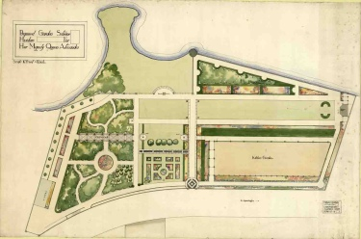

**Queen Alexandra’s villa in Denmark at Hvidore**

Copyright: Kendal Archive Centre http://www.cumbria.gov.uk/archives/whatsnew/news2011/aug2011news.asp

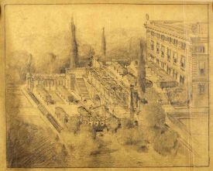

**Garden layout for the Royal Palace in Athens, 1914**

Copyright: Kendal Archive Centre http://www.cumbria.gov.uk/archives/whatsnew/news2011/aug2011news.asp

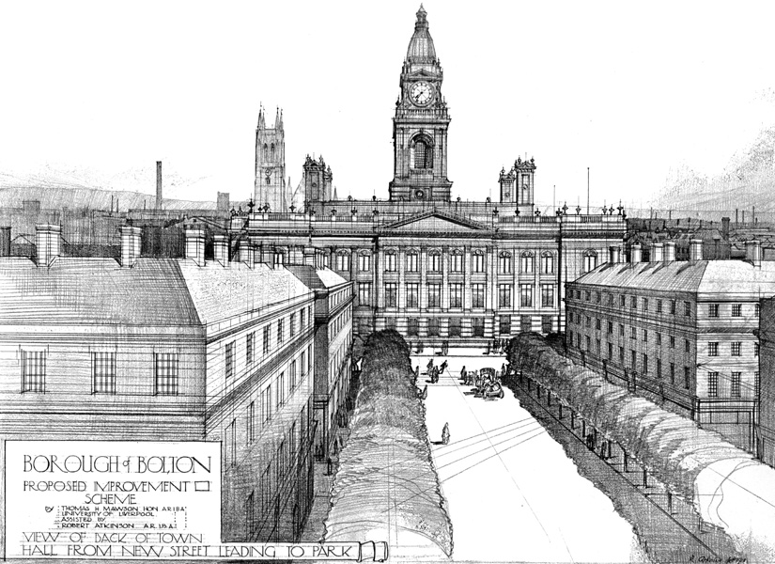

**Bolton, Proposed Improvement Scheme, 1911**

Copyright:

Mawson, T. H. (1911) **Civic Art** London:Batsford, p. 239.

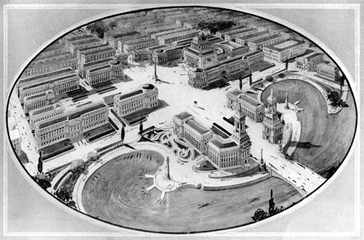

**Calgary Civic Centre Plan, 1914**

Copyright: City of Calgary Archives

http://www.thecanadianencyclopedia.com/articles/urban-and-regional-planninga